CpE 2211 Computer engineering lab
EXPERIMENTS 12 lab manual
Revised: J. Tichenor FS19; J. Stanley Summer 2022; J Stanley SS25
General sequence Counter
OBJECTIVES
In this experiment you will
- Design and build a general sequence counter with D-Flip Flops

LAB REPORTS
The format of lab reports should be such that the information can be used to reproduce the lab, including what values were used in a circuit, why the values were used, how the values were determined, and any results and observations made. This lab manual will be used as a guide for what calculations need to be made, what values need to be recorded, and various other questions. The lab report does not need to repeat everything from the manual verbatim, but it does need to include enough information for a 3rd party to be able to use the report to obtain the same observations and answers. Throughout the lab manual, in the Preliminary (if there is one), and in the Procedure, there are areas designated by Qxx followed by a question or statement. These areas will be bold, and the lab TA will be looking for an answer or image for each. These answers or images are to be included in the lab report. The lab TA will let you know if the lab report will be paper form, or if you will be able to submit electronically.
REFERENCES
Stanley/Woodley: Sections 7.1, 7.5
MATERIALS REQUIRED
Quartus II and QuestaSim
BACKGROUND
A general sequence counter is to be designed such that it counts in a clockwise fixed loop when input X is 1, and in a counterclockwise loop, skipping every other state, when X is 0, as shown in Figure 1. The output of your state machine should be its count. The specific count for each state will be given to you by your instructor. You should write the assigned count for each state in the state diagram of Figure 1.

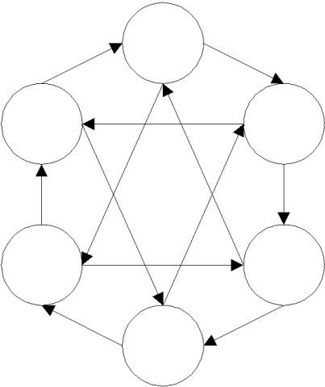

1

0

1

7

0

1

0

0

1

1

0

0

6

0

2

1

4

1

Figure 1: State Diagram of the General Sequence Counter.
PROCEDURE
- Design the counter shown in Figure 1 using as few logic levels as possible with D-Flip Flops. Include the following to documents for your design:
- state transition table
- next state equations
- schematic diagram
- state diagram including unused states

- Simulate your design using QuestaSim. Print out the logic diagram, and the waveforms for all possible state transitions.

- What are some typical applications of general sequence counters?
- What factors determine the maximum clock frequency?

